
- Ayush Architects

- \

SPACES FOR BETTER TOMMOROW

- 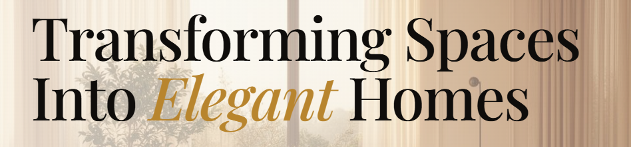

Where imagination takes form and every space tells a story.

- 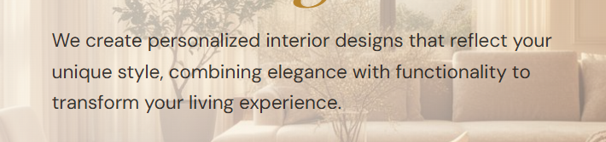

We bring your vision to life through thoughtful architecture that blends creativity, functionality, and timeless design, creating meaningful spaces that reflect your identity and tell a story of their own.

- 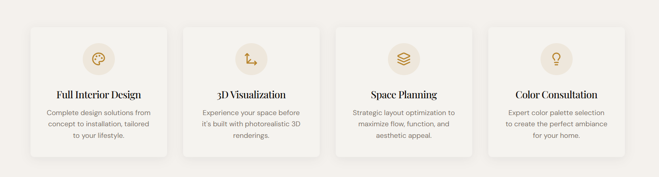
1. Architectural Planning
Complete architectural planning and design solutions for residential, commercial, and institutional projects.
2. 2D Floor Plans & Drawings
Detailed 2D floor plans, working drawings, furniture layouts, and construction drawings as per project requirements.
3. 3D Visualization
Realistic 3D models and renders to help you visualize your project before construction.
4. Space Planning
Efficient planning of spaces with a focus on functionality, circulation, comfort, and aesthetics.
5. Interior Design
Complete interior design solutions including furniture layouts, material selection, lighting, finishes, and detailed interior drawings.
6. Facade & Elevation Design
Modern and functional facade and elevation designs that enhance the appearance and character of your building.
7. Structural Planning
Structural drawings and planning for safe, stable, and efficient building structures.
8. Project Management
Professional project coordination and management to help ensure quality, timelines, and smooth execution.
9. Working & Construction Drawings
Detailed drawings required for site execution, including plans, sections, elevations, details, and construction information.
10. Landscape Design
Planning of outdoor spaces, gardens, pathways, plantations, and landscape elements to complement the building.
11. Renovation & Remodeling
Design solutions for renovating, upgrading, and transforming existing residential and commercial spaces.
12. Site Planning
Complete site development planning including building placement, circulation, parking, landscape areas, and other site requirements.

WE CAN ADD A FEW ON HERO PAGE AND EXTRA CAN BE KEPT IN “ EXPLORE ALL SERVICES”

- 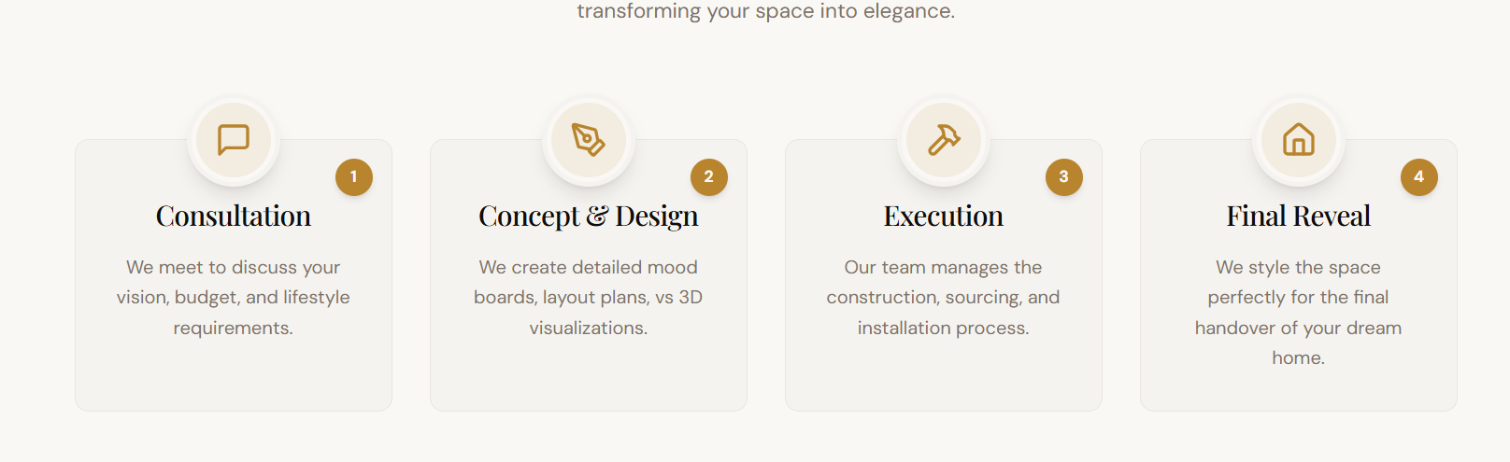

OUR DESIGN PROCESS

01. Consultation & Understanding
We begin by understanding your requirements, ideas, lifestyle, budget, site conditions, and project goals.

02. Site Study & Analysis
We study the site, dimensions, surroundings, orientation, access, regulations, and other factors that influence the design.

03. Concept & Design Development
We develop creative design concepts based on your requirements, combining functionality, aesthetics, and architectural character.

04. 2D Planning & Design
The selected concept is developed into detailed floor plans, elevations, sections, space planning, and other architectural drawings.

05. 3D Visualization
We create realistic 3D models and visualizations to help you understand the proposed spaces, materials, colours, and overall design before execution.

06. Design Finalization
We refine the design based on your feedback and finalize materials, finishes, furniture, lighting, and other important design elements.

07. Working Drawings & Documentation
Detailed working and construction drawings are prepared to provide clear information for execution at the site.

08. Execution & Project Coordination
We coordinate with contractors and other professionals to help ensure that the design is executed accurately and efficiently.

09. Quality & Design Review
Throughout the project, we review the work and design details to maintain consistency with the approved concept and drawings.

10. Final Reveal
The completed project is delivered as a finished space, bringing the original concept to life while reflecting your requirements and vision.
WE CAN ADD A FEW ON HERO PAGE AND EXTRA CAN BE KEPT IN “ EXPLORE ALL SERVICES”

- 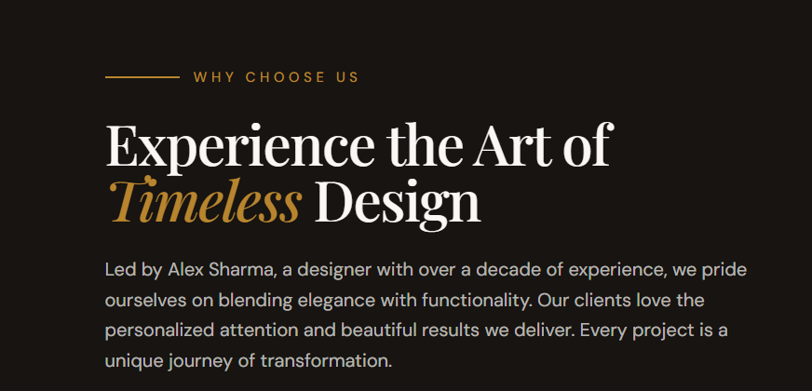
Led by Ayush , We combine creativity, functionality, and technical expertise to create spaces that are thoughtfully designed around your needs. From concept to execution, we focus on clear communication, attention to detail, quality, and personalized solutions to turn your vision into a well-designed and functional space.

- 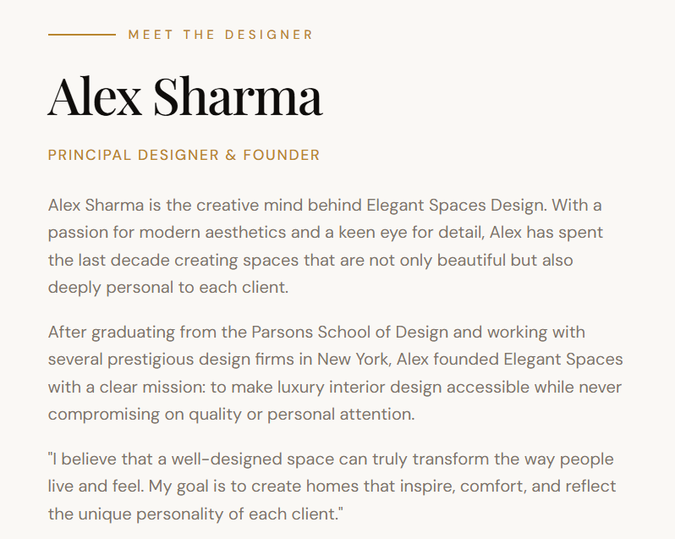

ABOUT US
Ayush Architects is an architecture and design studio creating thoughtful, functional, and distinctive spaces. From architectural planning and 3D visualization to interiors, elevations, and execution support, we provide complete design solutions tailored to every client.

OUR VISION
To create inspiring, functional, and timeless spaces that enhance the way people live and experience their surroundings.

FOUNDER'S MESSAGE
“Every project begins with a vision. Our role is to understand it, refine it, and transform it into a space that is functional, meaningful, and uniquely yours.”
— Ayush
Founder & Principal Architect, Ayush Architects

